**Criterion B: Design**

**Relationship between sprites**

Basic Design Overview of Product

Major Sprites:

* Bird
* Pipe
* Score  
   

1. Bird

The bird is the object that the player controls. This object is made up of multiple “costumes”/sprites that create an animation of flying during the gameplay.   
  

1. Bird actions

The bird will act upon the press of either the spacebar or mouse left-click. Not only does the sprite-change create a flapping animation, the change in sprites can also initiate a “flap-like” sound. And, this can be found in Appendix 1b. The bird can also interact with other objects such as the pipe and it can affect other objects such as the score, which will all be discussed further.

1. Pipe

The pipe acts as an obstacle towards the player, and the player must avoid using the bird object.

1. Pipe actions

In Appendix 1c, the set of commands show that the pipe can move its position up and down on the grid. Also, it clones itself after a certain number of horizontal grid movements. Moreover, the pipe will end the game if the bird comes into contact with it and end the animation of the bird. This can be referenced in Appendix 1d.

1. Score

This object uses both the pipe and bird objects to complete its objective, which is to count the player’s score.

1. Score actions

Since the score is dependent on the number of pipes the bird travels, every time the bird passes the pipe object, the “score” variable is used to add a “point”. And, every time a point is added, the sprite will change to the score number. Moreover, in Appendix 1e, it shows that using Scratch’s cloud software, the game can save a high score and this high score can be replaced with a higher score.

**Flowcharts**

1. Bird Animation

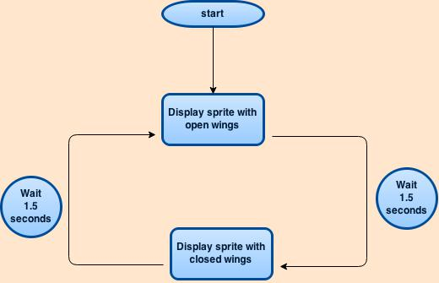

1. Pipe

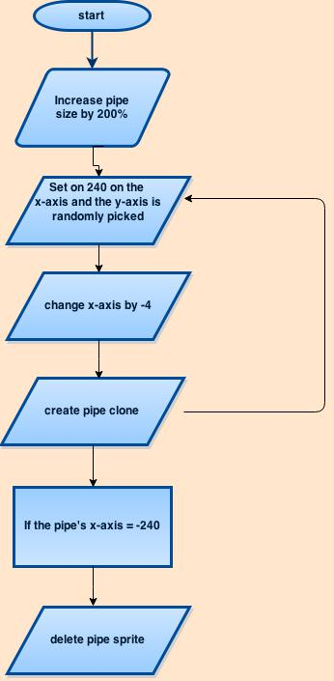

1. Score

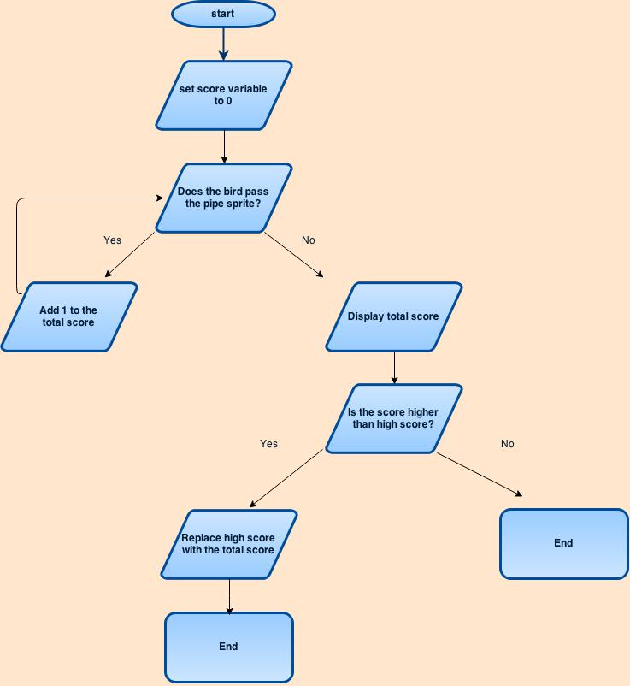

**Testing**

|  |  |
| --- | --- |
| Action to Test | Method of Testing and Result |
| Hardware functions correctly with hardware | Playing the game was the method of testing and the game responded well with the mouse clicks and spacebar clicks |
| Bird animation in-game | Play the game and we fixed the situation by making the bird’s “stand-by” time from 1 second to 0.1 seconds. |
| Synchronization with sound | Play the game and the sound effect would seem to occur immediately after the input from the user. |
| Game ends correctly | Initially, it did not end in the correct manner, but after fixing the problem, the game ends at appropriate times, which are when the bird hits the pipe or ground. |
| Game displays score | Yes, shows this with the ending menu that includes the current score and the final score. |